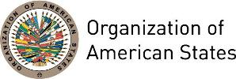
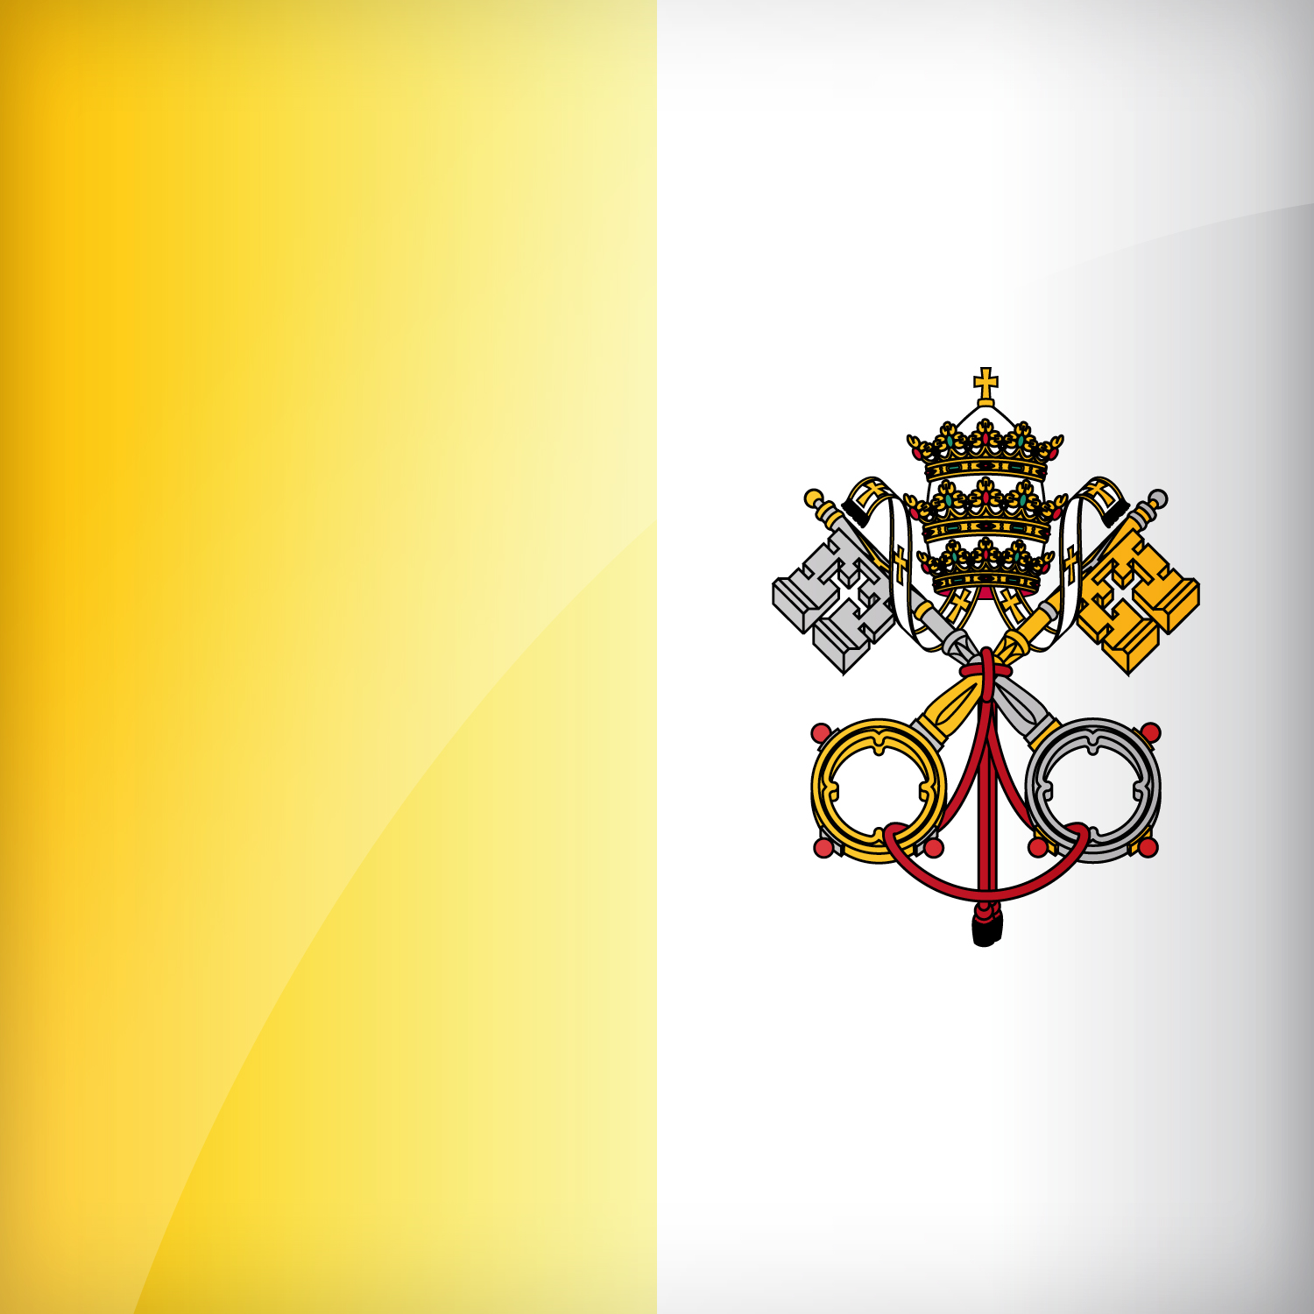
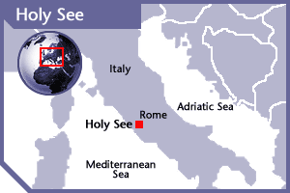


HOLY SEE
PERMANENT OBSERVER

HOLY SEE
PERMANENT OBSERVER

Date of Entry: July 1, 1978
National Day: March 13| April 23
Capital: Vatican City
Type of Government: Ecclesiastical Elective Monarchy
Head of State: Pope Leo XIV (May 8, 2025)
Secretary of State: His Eminence Cardinal Pietro Parolin (October 15, 2013)
Permanent Observer: Monsignor Juan Antonio Cruz Serrano (2021)

FOREIGN RELATIONS:
- The Section for Relations with States of the Secretariat of State deals with all matters pertaining to civil governments, fostering diplomatic relations with nations and maintaining contact with all the diplomatic missions of the Holy See, while also overseeing the presence and activity of the Holy See in international institutions.
- The Holy See conducts diplomatic relations through its Secretariat of State and its network of diplomatic posts (known as Apostolic Nunciatures) and maintains formal diplomatic relations with 183 countries. The Holy See has a unique role and standing in international affairs and plays an important role in several multilateral fora.
- The Holy See is Member, among others, of the Organization for Security and Cooperation in Europe, the United Nations Conference on Trade and Development, the International Migration Organization and the World Intellectual Property Organization. It has Observer Status to the United Nations, the World Health Organization (WHO), the World Trade Organization and many other international organizations. It is a party to a number of international instruments (including a series of international human rights treaties) and enjoys membership of various United Nations subsidiary bodies, specialized agencies and international intergovernmental organizations.
- The Holy See is active in United Nations (UN) debates, in particular on social and humanitarian issues.

International Policies of the Holy See:
The priorities and principles of the Holy See in its diplomatic activity include:
- Giving priority of the human person, of his dignity and rights;
- Promoting ethical and spiritual quality of life at each of its phases. “Human life at its conception, human life growing in the womb, life newly born, life as a child, a teenager, an adult… life that has grown old and is ready to pass away – and eternal life! Life that is family and community, life that prays and hopes. Life that is frail and sick, wounded, insulted, humiliated, marginalized and cast aside. All this is human life, the life of human persons who live on God’s earth and share our common home with every living creature” (Address of Pope Francis to Participants in the Plenary Assembly of the Pontifical Academy for Life, Clementine Hall, Vatican City, 25 June 2018);.
- Promoting justice and peace, especially through the respect of fundamental human rights;
- Promoting integral human development, with a particular attention to the need to be in solidarity with developing countries;
- Seeking the equality of nations and supporting all institutions that foster democracy as the basis of political and social life;
- Promoting conflict prevention and resolution in accord with the rule of law;
- Combatting human trafficking and protecting victims of forced labor;
- Promoting inter-religious dialogue and dialogue on environmental issues;
- Avoiding war and giving priority to negotiation and the use of juridical instruments;
- Striving for disarmament, especially of nuclear weapons.

HOLY SEE CONTRIBUTIONS:

YEAR | PROJECTS | FINANCIAL CONTRIBUTIONS  IN US$ | IN-KIND CONTRIBUTIONS  IN US$
2003 | Special mission: Strengthening the Democracy in Haiti | $5,000.00
2003 | Peace Fund: Sub-Fund Belize-Guatemala | $5,000.00
SUBTOTAL |  | $10,000.00
2008 | Department of Sustainable Democracy and Special Missions – Fund for Peace – Office of the General Secretariat in the Adjacency Zone between Belize and Guatemala | $5,000.00
SUBTOTAL |  | $5,000.00
TOTAL |  | $15,000.00

SOURCES:

HOLY SEE WEBSITE  http://www.vatican.va  VATICAN CITY STATE  http://www.vaticanstate.va/content/vaticanstate/en.html | THE PERMANENT OBSERVER MISSION OF THE HOLY SEE TO THE UNITED NATIONS (NY)  http://www.holyseemission.org/events/index.aspx?y=2013
This page was last updated in May 2025.

